
FINAL YEAR PROJECT REPORT

Musafirah
(Your safe journey, Synchronized)
A modern platform for trusted and secure women mobility

Syed Muhammad Abdullah
14431
Shayan Akram
14958
Taha Ahmed Khan
12126
Muhammad Usman
14680

Under the Supervision of
Sir Muhammad Zaid

2025-2026

ABSTRACT
Women in Pakistan still encounter obstacles during their daily travel because of safety issues, harassment and the absence of safe women-only transport alternatives. Although ride-hailing services like Yango inDrive and Bykea provide convenience they frequently do not fulfill the key needs of trust, safety and comfort for female riders.To tackle these challenges Musafirah is introduced as a carpooling app exclusively for women focusing on safety, dependability and cost-effectiveness, for female travelers.

The app, built with Flutter and connected to Firebase permits verified drivers to provide rides and lets women passengers participate in carpools according to common routes and timings. A multi-layered verification process involving CNIC and selfie checks along with OTP verification of mobile numbers guarantees the legitimacy of every user.Safety is a priority featuring real-time location tracking SOS emergency signals and alerts to trusted contacts, for prompt assistance and ongoing ride supervision.

Musafirah incorporates a cash payment method that is confirmed by both the driver and passenger accompanied by a payment confirmation alert to guarantee transparency and trustworthiness. Other features comprise adding passengers in time with the drivers consent, managing vehicle capacity providing ride reviews and ratings and allowing varied fare settings, for each passenger depending on the route or distance.

Beyond serving as a Final Year Project (FYP), Musafirah envisions evolving into a sustainable startup initiative that empowers women through safe mobility, promotes gender equality, and contributes to inclusive and accessible urban transportation in Pakistan.
ACKNOWLEDGEMENT
In the name of Allah, the most Gracious and the Most Merciful.
Peace and blessing of Allah be upon Prophet Muhammad ﷺ

First, praise of Allah, for giving us this opportunity, the strength and the patience to complete our FYP finally, after the challenges and difficulties. We would like to thank our supervisor _____________________________ for his guidance, motivation and most his significant contribution in this project, expert _______________________ and _______________________ for giving us the opportunity to work on this project. We would also like to thanks our parents for financial and moral support and our friends who have helped and motivated us throughout. May Allah reward them all abundantly. Ameen

DEDICATION
This report is dedicated to KIET University, our Teacher, our Supervisor, our Parents, our fellow colleagues and the hard-working students of KIET, with a hope that they will succeed in every aspect of their Academic Career and this project may help them in any aspect of their life.

TABLE OF CONTENTS
ABSTRACT 1
ACKNOWLEDGEMENT 2
DEDICATION 3
Table of Contents 4
TABLE OF CONTENTS 4
LIST OF FIGUERS 6
LIST OF TABLES 7
Chapter 1 – Introduction 8
1.1 Background & Motivation 8
1.2 Problem Statement 8
1.3 Objectives & Contributions 8
1.4 Scope of the Project 8
1.5 Report Organization 8
Chapter 2 – Literature Review 9
2.1 Introduction 9
2.2 Related Work 9
2.3 Comparative Analysis 9
2.4 Summary of Research Gap 9
Chapter 3 – System Design & Methodology 10
3.1 System Overview 10
3.2 Requirement Analysis 10
3.3 System Design Diagrams 10
3.4 Technologies & Tools Used 10
Chapter 4 – Implementation & Results 11
4.1 Development Environment 11
4.2 Implementation Details 11
4.3 Testing Strategy 11
4.4 Test Cases 11
4.5 Results & Evaluation 11
Chapter 5 – User Interface / Demonstration 12
5.1 Login Interface 12
5.2 Dashboard / Main Panel 12
5.3 Other Screens 12
Chapter 6 – Conclusion & Future Work 13
6.1 Limitations 13
6.2 Conclusion 13
6.3 Future Directions 13
References 14
Appendices 15

LIST OF FIGUERS
S.NO | Figure No. | Figure Name | Page No.
1 | Figure 1.4 | Project Scope | 5
2 | Figure 2.2 | Cloud Computing Model | 7
3 | Figure 3.1 | Use Case Diagram - Android Application | 13
4 | Figure 3.2 | Activity Diagram | 14
5 | Figure 3.3 | System Block Diagram | 14
6 | Figure 3.4 | System Architecture | 15
7 | Figure 3.5 | ER Diagram | 16
8 | Figure 3.6.1 | Raspberry pi Model B | 18
9 | Figure 3.6.2 | WIFI Router | 18
10 | Figure 3.6.3 | Android Phone | 19
11 | Figure 3.7.1 | LAMP Server | 19
12 | Figure 4.1 | Project Timeline | 23
13 | Figure 4.1 | Gantt Chart Summary | 23
14 | Figure 4.2 | Gantt Chart Details | 26
15 | Figure 5.1 | Login Interface | 33
16 | Figure 5.2 | Sign Up Interface | 33
17 | Figure 5.3 | Student Panel | 34
18 | Figure 5.4 | Teacher Panel | 34

LIST OF TABLES
S.NO | TABLE NO. | TABLE NAME | PAGE NO.
1 | Table No. 2.2 | Comparison Chart of Different Devices | 10

Chapter 1

Introduction

1.1 Background & Motivation
Everyday existence in Pakistan presents considerable difficulties for females, stemming from entrenched societal problems, an absence of secure travel options, and insufficient public amenities. Worries about personal security, along with the constant threat of molestation, significantly curb female movement, thereby impeding their ability to reach schooling, vocations, medical attention, and community involvement. Many reports indicate that a great deal of city women deliberately shun public conveyance or only journey when accompanied by male family members, apprehensive of assault, abuse, and the unreliability of current transit means. These travel constraints not only diminish their autonomy but also serve as an obstacle to their fiscal advancement and enablement.
While app-based summoning services like Yango, inDrive, and Bykea have brought increased adaptability and ease to metropolitan travel, they have not entirely met the distinct needs of women riders concerning security, reliability, and ease. A primary shortcoming of most of these channels is the lack of women-only preferences, solid identity confirmation methods, ongoing protection oversight, and built-in emergency reply functions, which leaves numerous women exposed to harassment or adverse incidents during their travels.
The Musafirah initiative was created precisely to combat these vital concerns by rolling out a protected, reasonably priced ride-sharing service solely for women. Musafirah intends to forge a reliable transit grid customized for the female segment by linking confirmed women drivers with women passengers within a safe and easy-to-use digital setting. Its attributes are crafted to maximize protection, clarity, and ease, encompassing layered user confirmation, live location tracing, immediate SOS warnings, alerts sent to specified trusted contacts, and a cash transaction method needing mutual acknowledgement by both the driver and passenger.

Musafirah is conceived as more than merely a technical remedy; it endeavors to strengthen females and foster gender parity. By enabling safer passage, the service aims to assist women in gaining the assurance and self-reliance necessary to chase educational, vocational, and communal prospects without apprehension or reliance on others. The central impetus behind this undertaking is the aspiration to foster a Pakistani transit setting that is markedly safer, more welcoming, and enabling, positioning the security and liberty of movement for women as its chief priority.

1.2 Problem Statement
Women in Pakistan still face major safety risks on public buses or ride-sharing apps. Many services skip tough driver checks, women-only rides, or live tracking. Women often feel scared to travel alone. They worry about harassment, fake drivers, or unknown men in the car. These fears cut back their travel. That hurts chances for school, work, and daily outings.
Demand rises for transport made just for women. Yet Pakistan has no women-only carpool app with full checks, open rules, and safe rides. So many women stick with male relatives or risky buses. This steals their freedom and calm.
The Musafirah App steps in with a women-only carpool. It checks every driver and rider by hand with ID scans, selfies, and phone codes. Key tools include ride tracking in real time, an SOS button, and alerts to trusted people for quick help.
Musafirah uses easy cash payments. Riders hand over money at ride's end. Both sides confirm it in the app. This sends auto notices to keep things clear and stop fights.
Musafirah gives women safe, steady rides they can trust. It boosts their confidence and freedom to go anywhere without fear.

1.3 Objectives & Contributions
The Musafirah App aims to build a safe carpooling service for women only. It addresses safety, trust, and convenience issues for female commuters in Pakistan. The app includes verified users, clear processes, and real-time safety features. Musafirah seeks to offer women a reliable ride option. This supports their freedom and daily activities. The project's main goals are as follows:
Objectives:
- Build a mobile app for women-only carpooling. It gives female riders safe, comfy, and low-cost travel choices.
- Set up a strict verification process. It uses manual CNIC checks, selfie scans, and OTP phone confirms. This proves drivers and riders are real and reliable.
- Add safety tools to rides. Use live GPS tracking, SOS alerts, and messages to trusted contacts. They provide fast help when needed.
- Launch a clear cash payment option. Drivers and riders both confirm the deal. An auto receipt then appears to stop arguments.
- Design an easy interface. Drivers can post rides quickly. Riders search and join by route and time matches. This raises ease of use.
- Build safe in-app chat. It fosters openness and trust. Women then feel sure about carpooling rides.
Contributions:
- We aim to build a safe, welcoming transport service designed just for women. It addresses their specific travel needs in Pakistan.
- This gives women dependable, solo travel choices. They gain better access to school, work, health care, and social events. No need for male relatives or risky public rides.
- We create a checked ride-share network run by the community. Strict user checks lower safety risks. It builds trust for women passengers.
- This sets up a startup ready to grow. It promises strong future expansion. It brings fresh tech-based transport ideas to Pakistan's cities.

1.4 Scope of the Project
The Musafirah App offers a safe carpooling service for women only. It puts safety, trust, and ease at the center. The app tackles travel problems for women in Pakistan. It gives a checked and open ride-sharing option.
Project Coverage:
- Build a mobile app with Flutter. Use Firebase for the back end..
- Handle three user types:
  - Rider (Driver): Women offering rides.
  - Customer (Passenger): Women booking and joining carpools.
  - Admin: Responsible for user verification through CNIC, selfie, and OTP confirmation.
- Add a cash payment system. Both driver and passenger check it. Then send a payment alert.
- Include SOS alerts. Send notices to trusted contacts for better safety.
- Link GPS API for live location and directions.
- Let passengers join rides in real time. Drivers must approve first.
- Manage vehicle space. Set limits on passengers per ride.
- Add reviews and ratings. This builds trust and keeps service good.
- Set fares for each passenger. Base it on route or distance.
Out of Scope:
● Online payment gateways and digital wallet systems.

● Rides for long distances.

● AI-powered ride suggestions or chatbot tools..

1.5 Report Organization
This report divides into six chapters. Each one follows a clear and logical path through the project development.
Chapter 1 gives a full overview of the project. It covers the background, reasons behind it, problem to solve, goals, and full scope. The chapter shows the need for a carpool app just for women in Pakistan. It lays the base for Musafirah.
Chapter 2 reviews past work. It looks at earlier studies, current transport tools, options for women on the move, and how ride-hail apps compare. The review points out good and bad points in existing systems. It spots the gap Musafirah will fill. This chapter sets the theory and backs the push for a safe, checked, and women-focused travel network.
Chapter 3 covers the system design and methods to build the app. It explains the full system view, what it must do and how well, design drawings, data paths, overall structure, and tools used. The chapter shows how parts fit to make a safe, live-update, easy-to-use carpool service.
The first three chapters build the project's ideas, analysis, and design base. They prepare for the build, tests, and outcomes in later parts. Readers grasp the drive, research support, and tech roots of Musafirah.

Chapter 2

Literature Review

2.1 Introduction
This literature review examines current research, technologies and ride-hailing services tied to women's mobility and safety. It checks popular apps like inDrive and Yango. It also looks at other transport choices meant for women. The goal is to see what they offer for checks, safety, and trust. Studies cover harassment, safety worries, and daily travel issues women face. The review makes one thing clear. Many standard ride-sharing apps ignore big gaps. They fail to build a real safe space women can trust. These problems show the need for a women-only platform. This part lays the groundwork for Musafirah. It is a safe, checked, and group-based carpool service for women passengers and drivers. The aim is to prove why it matters. It can truly boost women's travel options in Pakistan.

2.2 Related Work
Past research and current systems on ride-sharing and mobility for women show three main areas. General ride-sharing and carpooling studies form one. Work on women's travel and safety makes up another. Apps and services built for women-only rides complete the set.
2.2.1 General Ride-Sharing and Carpooling Literature
People have studied ride-sharing and carpooling in depth. They value the savings on costs and lower harm to the environment. These methods also tackle city travel woes. Research on smart carpool apps looks at how they track user trips and pair rides well. That work highlights problems in user-system links. It stresses trust between people and the app. Take the study called Efficient and Privacy-Preserving Ride Sharing Organization for Transferable and Non-Transferable Services. It brings scalable ride plans with solid privacy shields and crypto proofs. In all, these efforts make clear that ride platforms need more than basic matches. They must guard user privacy, scale up, foster trust, and add strong checks.
2.2.2 Ride-Hailing and Carpooling Technologies
Services like Uber, inDrive, and Careem changed city travel. They link riders to drivers via phone apps. These apps use AI to match rides, GPS to follow routes, and reviews to build trust. Riders gain easy access and low costs. Still, the apps miss needs tied to gender. Women often feel unsafe or face harassment from male drivers or other passengers. No rides just for women hurt safety most. Checks on drivers stay too weak. The study Driving Toward Equality (IFC, 2018) shows these apps aid women. To include all, they need stronger safety rules and better ID checks.

2.3 Comparative Analysis
A comparison review checks current ride-hailing and carpooling apps against the Musafirah App. It shows differences in goals, users, safety tools, and user checks. Apps like Careem, inDrive, and Uber run in Pakistan. They aim at all people. They lack rides just for women. Women-only apps such as SheDrive, Roshni Rides, and SheCab offer female rides. But they lack full country coverage, deep user checks, or clear payment info. This part sets these apps side by side with Musafirah. It proves the app's special strengths.
2.3.1 Key Findings from Comparison
The analysis reveals several key findings that establish the need for Musafirah:
- Limited Verification in Existing Apps:
Current ride apps check only drivers or do basic ID reviews. Musafirah adds full checks for drivers and riders. It uses CNIC, selfies, and OTP codes.
- Inadequate Safety Mechanisms:
Apps like Uber and Careem offer ride tracking. But they miss real-time SOS buttons and alerts to trusted contacts for women. Musafirah adds constant watch and quick emergency notices.
- Cash-Based but Transparent Payment:
Most apps take cash or digital payments without both sides agreeing. Musafirah requires driver and rider to confirm cash first. Then the app logs it for clear records.
- Gender-Focused Accessibility:
Other apps mix men and women riders. Musafirah builds a safe space just for women. It brings comfort, trust, and jobs for female drivers.
- Nationwide Scalability and Inclusivity:
Services like SheDrive, SheCab, and Roshni Rides stick to big cities. Musafirah plans to grow all over Pakistan. This makes safe rides open to women everywhere.

2.4 Summary of Research Gap
Research and ride apps show clear advances in online taxi and carpool services. Key problems linger, though. They center on women's safety, ID checks, and access in Pakistan's transport system. Apps like inDrive, Careem, and Uber offer basic rides for all. They skip women-only spaces. This leaves female riders open to harassment and unease. Driver checks work well on these platforms. Passenger checks stay weak or absent. Trust and safety take a hit.
Services like SheDrive, SheCab, and Roshni Rides offer women safer ride options. But they lack reach, size, and tech features. Most run in just a few cities. They skip live tracking, SOS buttons, and links to trusted contacts. Riders need these for steady safety. Many apps use unchecked payments or one-way systems. This starts fights and hides facts from riders and drivers.
The Musafirah App fixes these issues. It brings a full women-only carpool service. This service checks users in steps: CNIC, selfie, and OTP. It adds live tracking and emergency alerts. Cash payments get checked by both driver and rider.This mix creates trust, openness, and safety for the whole trip.Musafirah builds women's strength and free movement. It covers a big need in Pakistan's ride services. The app offers a safe, open, and growing option for women riders..

Chapter 3

System Design & Methodology

3.1 System Overview

The application operates on a dual-user structure—one module for drivers who wish to offer rides and another for passengers seeking to book them. Both user types must complete a multi-step verification process, including profile creation, selfie verification, and OTP-based phone confirmation, before accessing the system. This process helps establish user authenticity and builds a trusted community of women travelers.

Technically, the app is developed using Flutter, enabling smooth performance across both Android and iOS platforms with an intuitive interface. The backend employs Firebase for user authentication, data management, and real-time synchronization. Through Google Maps API and Geolocation services, Musafirah supports live tracking, accurate route mapping, and efficient ride coordination.

For safety and peace of mind, the application integrates live location sharing, an SOS emergency button, and real-time ride updates, allowing users to share trip details with trusted contacts or alert authorities in emergencies. Furthermore, Musafirah offers cashless payment options through local digital payment gateways like Easypaisa, JazzCash, and NayaPay, ensuring financial security and ease of use.

Beyond its technical features, Musafirah represents a socially impactful initiative aimed at empowering women and promoting independent mobility. It aligns with several UN Sustainable Development Goals (SDGs), including Gender Equality, Decent Work and Economic Growth, and Sustainable Cities and Communities, making it both a practical and socially meaningful innovation.

3.2 Requirement Analysis
Functional Requirements
- User Registration and Authentication:
Drivers and passengers can set up accounts with ease on the platform. A basic sign-up form needs just key details to begin. OTP checks make sure each user's identity and phone number are real. Safe login options guard user data every time. The system includes password reset and account recovery features too. Sign-up stays simple, fast, and secure for all.

- Profile Management:
Users can update personal info anytime they want. They add or switch profile photos to build trust. Drivers upload details like car model, license plate, and color. Both drivers and passengers see exactly what info they share. The edit screen feels easy and user-friendly. This creates openness and trust between users.

- Ride Creation and Search:
Drivers set up rides by picking start point, end point, date, and time. They choose seat count and extra options. Passengers search for rides that match their route and schedule. Filters help narrow by closest pickup, price range, or driver rating. Map views show routes clearly. Drivers and passengers match up fast and easy.

- Booking and Confirmation:
The booking process needs to be easy and clear. Passengers can send ride requests to drivers with one tap. Drivers get these requests right away. They can decide fast based on open seats or their own choices. When a driver accepts, both get a clear message at once. The app shows key details like pickup time, seat count, and meeting spot. Both know what to expect. This keeps things neat, open, and calm for all.

- Live Tracking and Navigation:
Use Google Maps for live tracking and navigation. It gives exact route info in real time. Passengers see the driver's spot before and during the ride. Drivers get the best routes built in for easy travel. The app updates arrival times and route status non-stop. Users stay in the know. This adds trust and cuts down on extra talk. Live tracking brings safety, ease, and links for everyone.

- Safety Features:
Build safety deep into the app for drivers and passengers. Add an SOS button for quick help in emergencies. Users can share their live spot with trusted people right away. Alerts send exact location for fast aid. Keep full ride records for clear records. These tools make a safe, reliable space. They matter most for rides just for women or safety-first shares.
- Payment Integration:
Link payments for a smooth cash-free flow with Easypaisa, JazzCash, and NayaPay. Passengers pay fares at once with no cash. This makes it safer and simpler. Show a full fare split before the ride locks in. Drivers get payment alerts when done. Handle refunds or changes for cancels on auto. The setup stays safe, clear, and simple to use.

- Push Notifications:
Push alerts keep users updated on every ride step. Riders and drivers get notices for requests, accepts, or turns-downs right away. Send updates for driver arrival, ride start, and end in real time. Include safety notes, payment checks, and emergency warnings. Use plain, simple words in each. Alerts make sure of good teamwork and steady updates all trip long.
Non-Functional Requirements
- Performance:
The app must load in less than three seconds. Users get a quick start. It handles many users at once without slowdowns or crashes. Screens shift smoothly. Searches return fast results. Actions respond right away. These keep users at ease and build trust. The system manages background tasks well, like location checks and alerts. Speed stays even during busy hours. A quick and steady app builds user trust and boosts daily use.

- Scalability:
The system needs design for fast user growth. Speed and features stay strong as drivers and riders increase. It scales out or up with demand. Rush hours or events cause no issues. Smart resource use lets the backend grow with ease. This lets the platform expand as need rises.

- Security:
Security ranks first. The app holds key data like phone numbers, real-time spots, and payments. Encrypt all data in storage and transfer. Use strong login methods to guard accounts. Run checks and updates often to spot weak spots. Follow safe code rules and top standards. A safe setup earns trust and guards users.

- Usability:
The app interface needs to be simple and easy to use for people of all ages and backgrounds. Buttons, menus, and screens should feel natural, clear, and quick to respond. Android and iOS versions must run smoothly with matching design and actions. Loading screens, animations, and small touches guide users with no hassle. Accessibility tools help those with disabilities. The full experience feels warm, fresh, and calm.

- Reliability:
The system works steady each time. Users get stable service and rides they can count on. Data on drivers, bookings, and confirmations stays in sync live. It handles crashes, network problems, and heavy use without fail. Backups save all ride details. Checks find issues before they hit users. Steady work builds trust over years.

- Maintainability:
The structure stays clean and split into parts. Updates come easy as new features join. Teams fix bugs or tweak sections without breaking the whole app. Clear notes and code rules aid group work. Growing APIs and shared parts speed up new builds. Safe tests and releases keep things smooth. This setup lasts long and boosts fresh ideas.

3.3 System Design Diagrams
3.3.1 Flow Chart Diagram
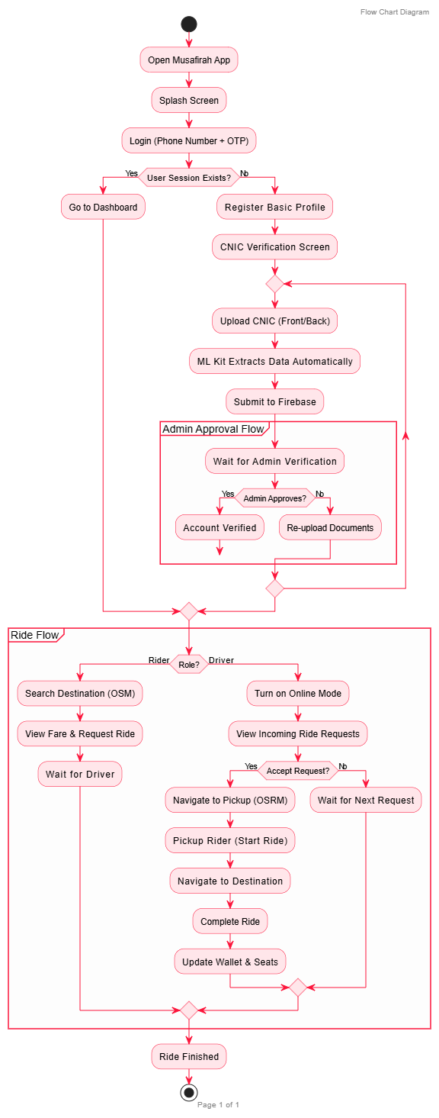
3.3.2 ERD Diagram

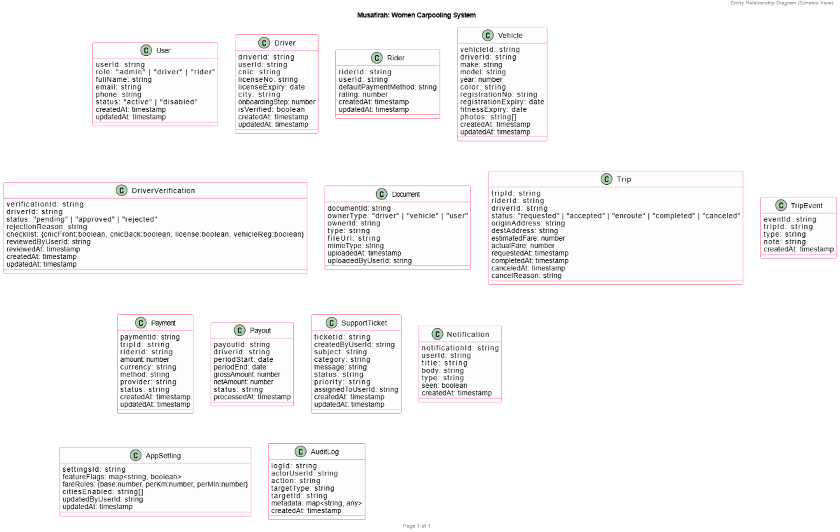

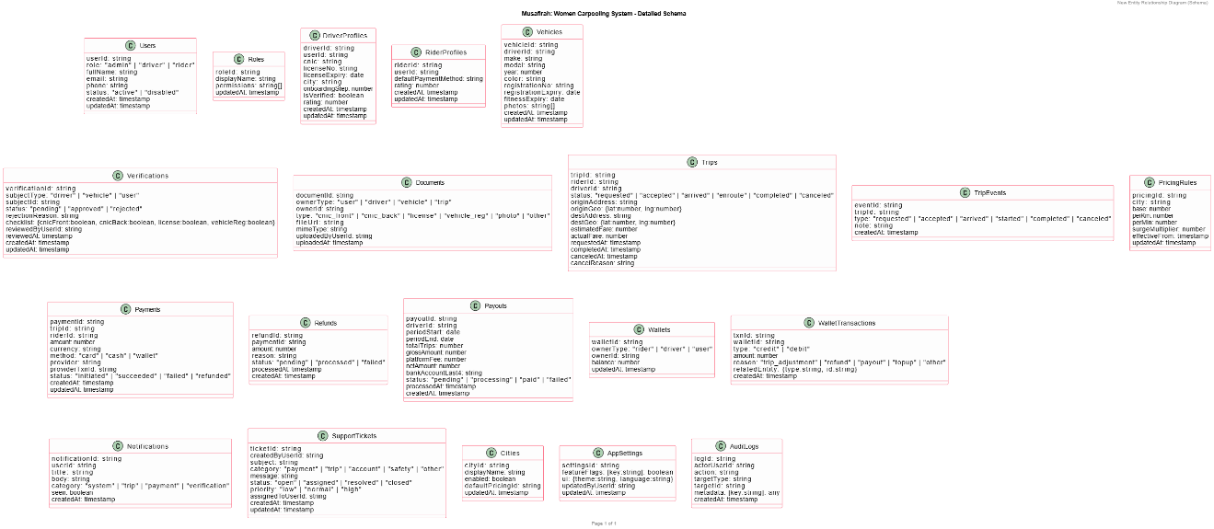

3.3.3 Class Diagram
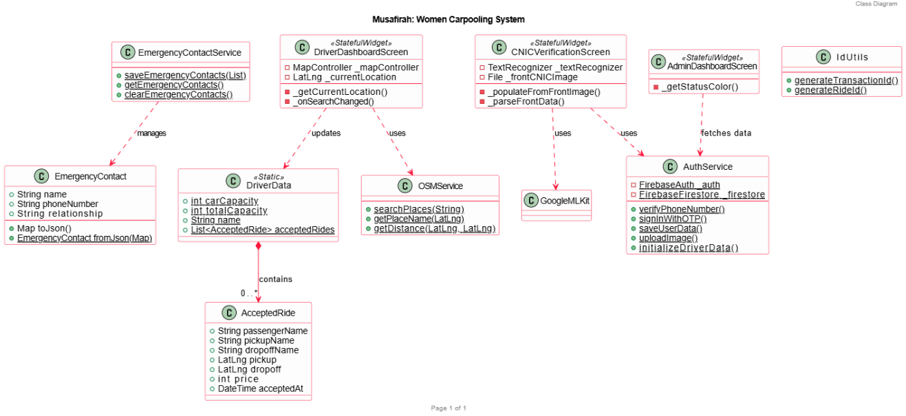
3.3.4 Use Case Scenario
Use Case Scenario: End-to-End Ride Journey in Musafirah
The journey begins with the Registration and Verification phase, where a new user (either a Rider or a Driver) signs up using their phone number and verifies it via a Demo OTP system. To ensure a safe environment for women, the user must upload their CNIC documents. The application utilizes the Google ML Kit Text Recognition API to automatically extract the name, CNIC number, and expiry dates from the images to minimize manual entry errors. Once submitted, the profile enters a "Pending" state, awaiting manual review by the System Administrator through the Admin Panel. After the Admin verifies the documents and grants approval, the user gains full access to the platform.

The Ride Initiation phase starts when a verified Rider searches for a destination on the Map Dashboard. The application calls the OpenStreetMap Nominatim API to provide real-time address suggestions based on the user's search query. Upon selecting a destination, the system calculates the estimated fare and distance using the Haversine Formula. Once the Rider requests the ride, the request is broadcasted to nearby verified Drivers. A Driver viewing her Ride Requests screen evaluates the pickup and drop-off points and chooses to accept the ride.

In the Execution and Completion phase, the Driver uses the integrated Navigation feature, which leverages OSRM (Open Source Routing Machine) to plot the most efficient road route. If there is any confusion regarding the pickup point, the Rider and Driver communicate through the in-app Chat system. After the Rider is picked up and reaches her destination, the Driver marks the ride as complete. This action triggers an automatic State Change: the Driver’s digital wallet is updated with the earned fare, the vehicle's seating capacity is reset, and the ride record is archived in the Firebase Firestore database for future history. This end-to-end flow ensures a secure, transparent, and efficient carpooling experience specifically tailored for women.

3.3.5 Use Case Diagram

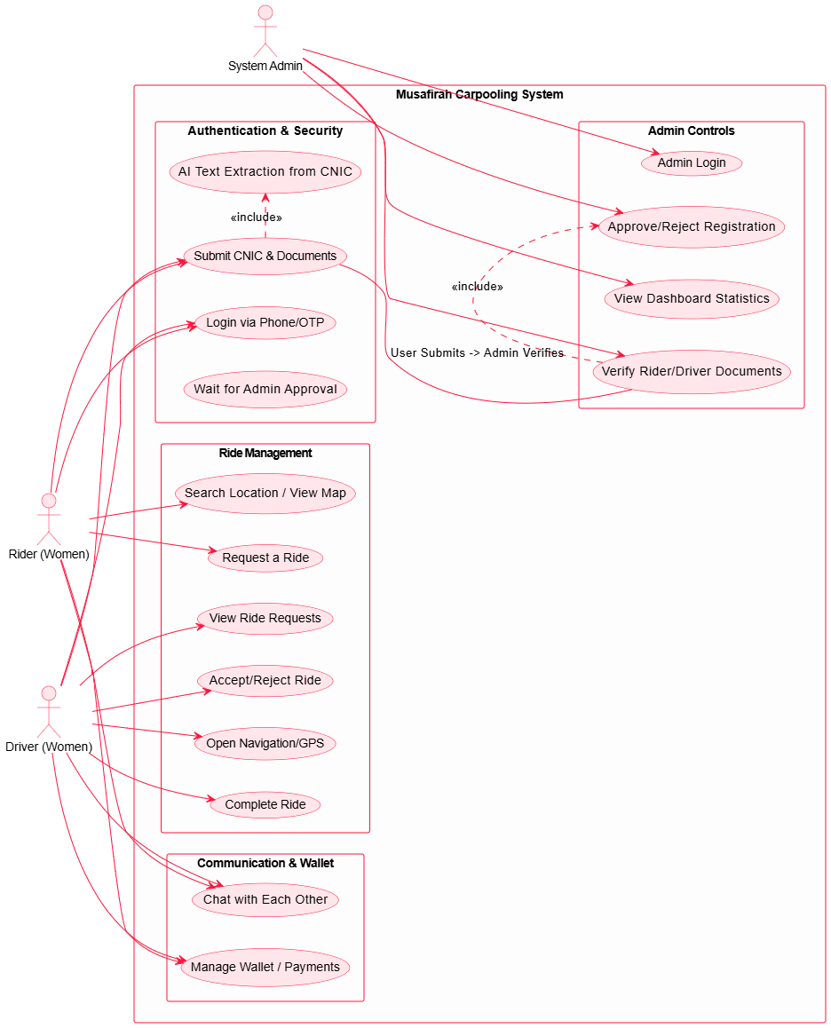

3.3.6 Use Case Generalization Diagram
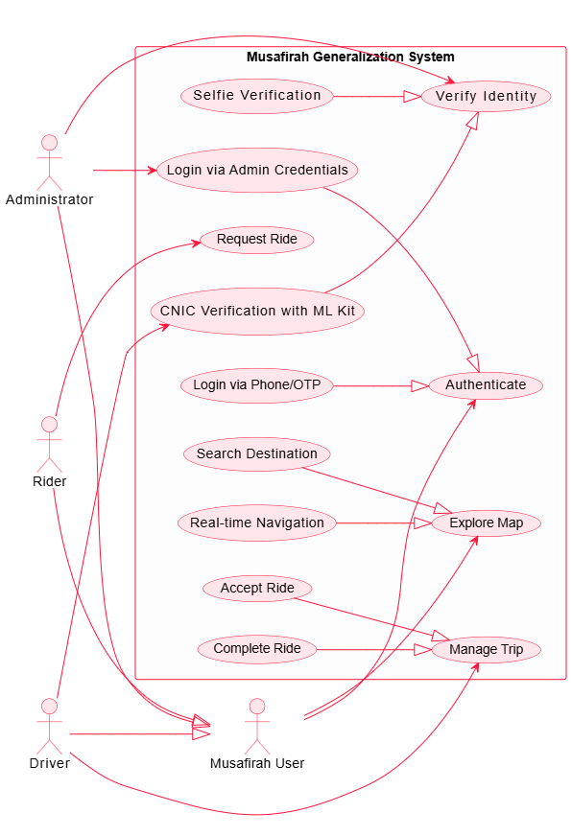
3.3.7 Activity Diagram

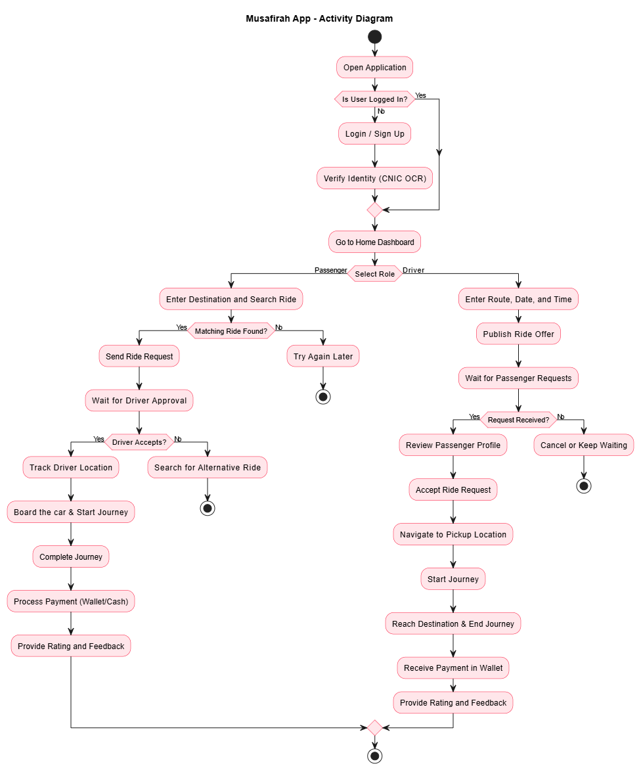

3.3.8 Swimlane Diagram
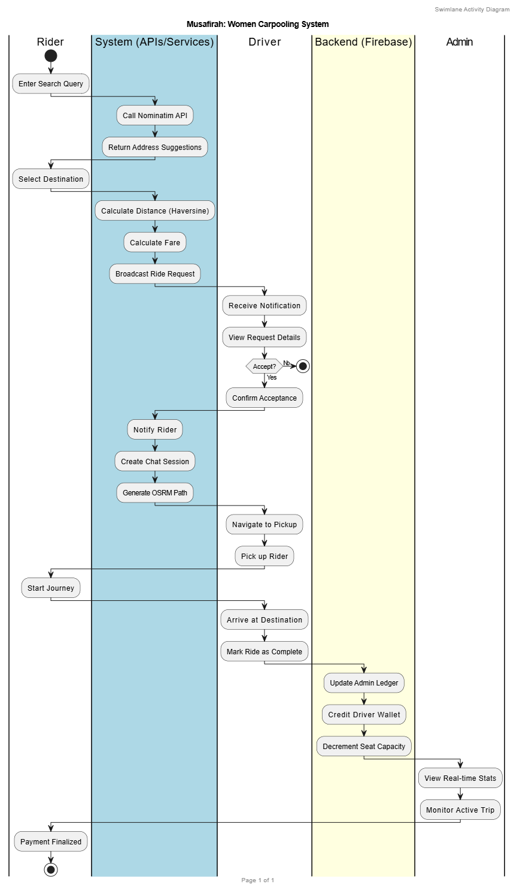
3.3.9 Sequence Diagram
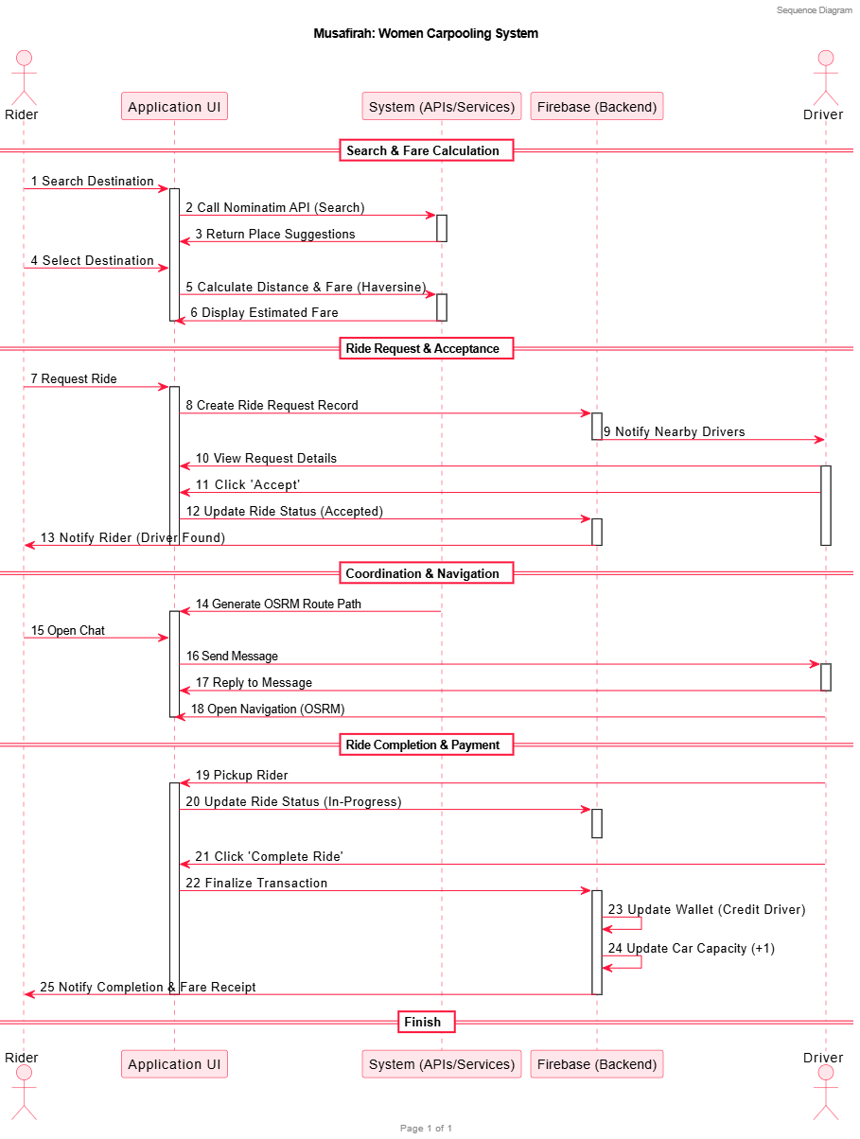

3.3.10 Collaboration Diagram

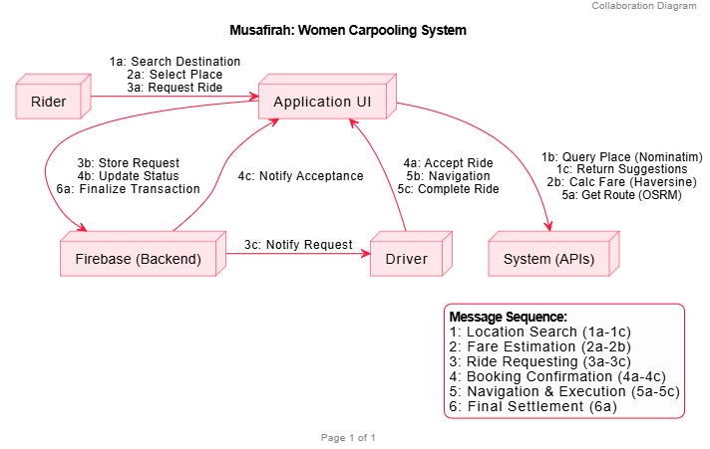
3.3.11 Deployment Diagram
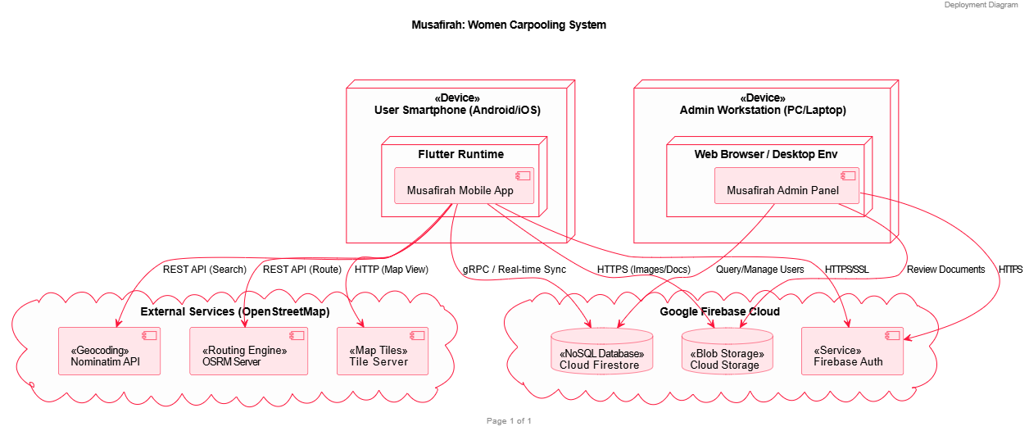

3.4 Technologies & Tools Used
Software Requirements
- Operating System:
Android (Version 8.0 and above) — chosen for its wide adoption and affordability among Pakistani users, ensuring accessibility and market reach.
- Development Framework:
Flutter SDK provides a unified environment for creating modern, responsive, and attractive Android interfaces. It supports fast development and delivers near-native performance.
- Backend and Database:
Firebase used for user authentication, data storage, and real-time synchronization. It offers scalability, security, and reliability without needing a self-hosted server.
- APIs and Libraries:
  - Open Street Maps API for ride tracking and route visualization.
  - Geolocation Services for detecting live locations.
  - Payment (By Cash) for secure and delay purpose.
- Development Tools:
  - Antigravity: used for running emulators, compiling APKs, and handling Gradle builds.
  - Visual Studio Code (VS Code): lightweight and ideal for fast coding, debugging, and managing Flutter widgets.
  - GitHub: facilitates version control and collaborative teamwork.

Hardware Requirements
- Development System:
  - MacBook Pro (2019) or laptop with Intel Core i5/i7, 8 GB RAM, and 256 GB SSD for smooth execution of Android Studio, VS Code, and Firebase integration.
  - Android smartphones for app testing and debugging.
- Network Requirement:
Stable internet connection (minimum 10 Mbps) for real-time Firebase operations, API calls, and live tracking.

Chapter 4

Implementation & Results

4.1 Development Environment
The development of the Musafirah women's carpooling mobile application was carried out utilizing a robust and modern technology stack tailored for cross-platform mobile development. The primary framework selected for this project is Flutter, an open-source UI software development kit created by Google. Flutter was chosen for its inherent ability to compile natively to both Android and iOS platforms from a single codebase, significantly reducing development time while maintaining optimal native performance. The application's logic and behavior are written in Dart (v3.9.2+), an object-oriented, strongly typed programming language optimized for fast, reactive UI rendering.

For the Integrated Development Environment (IDE), Visual Studio Code (VS Code) and Android Studio were utilized. VS Code served as the primary, lightweight code editor, equipped with Flutter and Dart extensions for seamless syntax highlighting, debugging, and code completion. Meanwhile, Android Studio was essential for managing the required Android SDKs, configuring Android Virtual Devices (emulators) for active testing, and handling native Android build configurations.

The backend infrastructure relies on Firebase, a comprehensive Backend-as-a-Service (BaaS) platform. The application employs Firebase Authentication for secure and verified user login, Cloud Firestore as a scalable NoSQL cloud database to store user profiles, ride listings, and real-time state changes, and Firebase Cloud Storage for securely managing user-uploaded media like profile pictures and identity documents.

Furthermore, the environment integrates specialized libraries to handle core application features. This includes Flutter Map (using OpenStreetMap) and Geolocator for real-time location tracking, dynamic mapping, and routing functionalities. For enhanced security and automated user verification, Google ML Kit was integrated to process on-device Optical Character Recognition (OCR) via the smartphone camera. The combination of these sophisticated tools provided a highly efficient, scalable, and secure foundation for the Musafirah application.

4.2 Implementation Details
The Musafirah application was developed using a highly modular architecture, ensuring separation of concerns, long-term scalability, and robust security. The system integrates various cutting-edge technologies, including the Flutter framework for the frontend architecture, Firebase for real-time backend synchronization, and on-device Machine Learning for automated verification. Below is a comprehensive overview of how the key system modules were implemented across the project infrastructure.
4.2.1 Identity Verification Module (Google ML Kit)
To ensure the absolute safety of the women-exclusive platform, rigorous driver onboarding mechanisms were implemented. Instead of relying solely on manual administrative checks, we integrated Google ML Kit within the CNICVerificationScreen to perform on-device Optical Character Recognition (OCR). This module captures the user’s National Identity Card (CNIC) through the camera, automatically extracting textual data to validate the physical document format before it is transmitted to the cloud.
cnic_verification_screen.dart
final textRecognizer = TextRecognizer(script: TextRecognitionScript.latin);
final RecognizedText recognizedText = await textRecognizer.processImage(inputImage);
String extractedText = '';
for (TextBlock block in recognizedText.blocks) {
extractedText += block.text + '\n';
if (RegExp(r'^\d{5}-\d{7}-\d{1}$').hasMatch(block.text)) {
setState(() {
_cnicNumber = block.text; // Extracted accurately
});
}
}
textRecognizer.close();
By performing OCR locally on the smartphone’s processor, the system drastically reduces manual data entry errors, accelerates the onboarding pipeline, and minimizes sensitive data transmission prior to robust local validation.
4.2.2 Financial and Wallet Management Module
A seamless transactional experience is critical for a carpooling ecosystem. To manage in-app currency, automated ride deductions, and driver earnings, a dedicated Wallet Repository was implemented. This module operates as a centralized data layer, tracking localized transactional history (WalletEntry), formatting timestamps, and calculating real-time financial balances dynamically without burdening the UI rendering thread.
Code Snippet: Dynamic Balance Calculation (wallet_repository.dart)
class WalletRepository {
// Reduces all transaction entries to a single dynamic balance
static double get balance =>
_initialBalance +
_entries.fold<double>(0, (sum, entry) => sum + entry.amount);
static void recordRideCompletion({
required String rideId,
required double fare,
required DateTime timestamp,
bool isWalletPayment = false,
}) {
if (isWalletPayment) {
_entries.insert(0,
WalletEntry(
id: IdUtils.generateTransactionId(),
title: 'Ride Payment',
amount: -fare, // Deducting calculated fare from wallet
timestamp: timestamp,
type: WalletEntryType.ridePayment,
),
);
}
}
}
This repository pattern allows the application to cleanly decouple financial validation logic from the presentation screens. The active use of Dart’s collection methodologies (like fold) ensures that the user's current wallet balance is an instantly accurate reflection of their complete transaction timeline.
4.2.3 Geolocation and Dynamic Routing Module
Location tracking and fare estimation form the operational backbone of Musafirah. To provide highly customizable and cost-effective mapping, we bypassed traditional paid APIs in favor of OpenStreetMap (OSM) integrated via the OSMService class.
For instant, pre-ride fare calculations, the system relies on the mathematical Haversine formula. Implemented directly in Dart, this algorithm rapidly calculates the great-circle spherical distance between the rider’s pickup and drop-off (LatLng) coordinates.
Code Snippet: Distance Calculation Algorithm (osm_service.dart)
static double getDistance(LatLng origin, LatLng destination) {
const double earthRadius = 6371; // Earth's Radius in kilometers
final double lat1Rad = origin.latitude * (math.pi / 180);
final double lat2Rad = destination.latitude * (math.pi / 180);
final double deltaLatRad = (destination.latitude - origin.latitude) * (math.pi / 180);
final double deltaLonRad = (destination.longitude - origin.longitude) * (math.pi / 180);
final double a = math.sin(deltaLatRad / 2) * math.sin(deltaLatRad / 2) +
math.cos(lat1Rad) * math.cos(lat2Rad) *
math.sin(deltaLonRad / 2) * math.sin(deltaLonRad / 2);
return earthRadius * (2 * math.atan2(math.sqrt(a), math.sqrt(1 - a)));
}
Calculating distances completely off-grid computationally eliminates the need to ping external routing servers just for initial fare estimates, noticeably improving the application's responsiveness in zones with weak mobile internet connectivity.
4.2.4 Real-Time State Synchronization and UI Architecture
The presentation layer of the application was constructed using Flutter, leveraging robust stateful methodologies to ensure that the interface actively reflects backend state changes. Rather than repeatedly polling servers for ride status updates, the app heavily relies on Firebase Firestore’s snapshot listeners.
When a driver modifies the status of an active ride (e.g., transitioning from "Requested" to "En Route"), the DriverDashboardScreen executes a transactional write to Firestore. Instantly, the PassengerDashboardScreen listening to that specific ride document receives the mutated data payload via WebSockets and triggers a selective widget rebuild. This publish-subscribe architectural pattern heavily suppresses visual latency, ensuring that riders and drivers remain perfectly synchronized throughout the journey, while custom component libraries sustain Musafirah's visual brand identity.

4.3 Testing Strategy
Software testing in your application follows a layered approach where different levels ensure quality from small features to the complete system.
1. Unit Testing
Unit testing focuses on individual features and validations. In your application, this is reflected in test cases that check specific inputs and outputs, such as login field validation (empty email, wrong password), signup form errors (invalid email, short password), and OTP verification. Each small function, like form validation, button action, or field check is tested independently to ensure it works correctly before moving to the next stage.
2. Integration Testing
Integration testing verifies how different modules work together. Your application includes multiple connected flows such as authentication, registration, document verification, and dashboard navigation. For example, after a user signs up, the system moves through CNIC verification, license/vehicle info, selfie verification, and finally the dashboard. This level ensures that data flows correctly between UI, backend (Firebase) and different modules without breaking the process.

3. System Testing
System testing evaluates the complete application as a whole. Your test cases cover full workflows like ride booking, driver acceptance, navigation, chat system, wallet transactions, and admin management. It also includes edge cases such as no internet, permission denial, and error handling. This level ensures that the entire system works properly in real-world scenarios, including UI behavior, performance, and overall functionality.

4. User Acceptance Testing (UAT)
User Acceptance Testing is based on real user roles in your application Passenger, Driver, and Admin. Each role has its own dashboard and features and UAT ensures that these users can perform their tasks easily, such as booking rides, accepting trips, managing profiles, and handling approvals. At this stage, the focus is on user satisfaction and whether the system meets practical requirements before final deployment.

4.4 Test Cases
  - Splash Screen & App Launch
TC ID | Description | Preconditions | Test Steps | Expected Result | Priority | Status
TC-SP-0 1 | App launches and splash screen is displayed | App installed on device | 1. Open Musafirah app | Musafirah logo and tagline appear with animation | High | Pass
TC-SP-0 2 | Auto-navigation after 3 seconds | Splash screen displayed | 1. Wait 3 seconds on splash screen | App navigates automatically to User Choice screen | High | Pass
TC-SP-0 3 | Tagline text is correct | App launched | 1. Observe splash screen text | Tagline reads: 'Your safe journey, synchronized' | Low | Pass

- User Role Selection
TC ID | Description | Preconditions | Test Steps | Expected Result | Priority | Status
TC-UC-0 1 | Three role cards displayed | User on User Choice screen | 1. Navigate to User Choice screen | Passenger, Driver, and Admin cards are visible | High | Pass
TC-UC-0 2 | Passenger Login button navigates correctly | User on User Choice screen | 1. Tap 'Log In' on Passenger card | Navigates to Email Password Login screen with 'Passenger' role label | High | Pass
TC-UC-0 3 | Driver Login button navigates correctly | User on User Choice screen | 1. Tap 'Log In' on Driver card | Navigates to Email Password Login screen with 'Driver' role label | High | Pass
TC-UC-0 4 | Passenger Sign Up button navigates correctly | User on User Choice screen | 1. Tap 'Sign Up' on Passenger card | Navigates to Passenger Email Signup screen | High | Pass
TC-UC-0 5 | Driver Sign Up button navigates correctly | User on User Choice screen | 1. Tap 'Sign Up' on Driver card | Navigates to Driver Email Signup screen | High | Pass
TC-UC-0 6 | Admin card has no Sign Up button | User on User Choice screen | 1. Observe Admin card | Only 'Log In' button visible; no 'Sign Up' button on Admin card | Medium | Pass
TC-UC-0 7 | Admin Login button navigates correctly | User on User Choice screen | 1. Tap 'Log In' on Admin card | Navigates to Admin Login screen | High | Pass
TC-UC-0 8 | Entry animations play on screen load | User navigated from Splash | 1. Observe cards on screen entry | Cards slide and fade in smoothly | Low | Pass

- Authentication – Login (Email & Phone)

TC ID | Description | Preconditions | Test Steps | Expected Result | Priority | Status
TC-AU-0 1 | Login screen shows Passenger role badge | Tapped Passenger login from User Choice | 1. Observe header badge on Email Login screen | Badge shows 'Passenger Login' with person icon | High | Pass
TC-AU-0 2 | Login screen shows Driver role badge | Tapped Driver login from User Choice | 1. Observe header badge on Email Login screen | Badge shows 'Driver Login' with car icon | High | Pass

TC ID | Description | Preconditions | Test Steps | Expected Result | Priority | Status
TC-AU-0 3 | Welcome text is role-specific | Role passed to Email Login screen | 1. Observe welcome heading | Shows 'Welcome Aboard, Passenger!' or 'Welcome Aboard, Driver!' | High | Pass
TC-AU-0 4 | Empty email field shows validation error | Email Login screen open | 1. Leave email empty 2. Tap Log In | Validation error: 'Email is required' | High | Pass
TC-AU-0 5 | Empty password field shows validation error | Email Login screen open | 1. Enter valid email 2. Leave password empty 3. Tap Log In | Validation error: 'Password is required' | High | Pass
TC-AU-0 6 | Wrong credentials show error snackbar | Email Login screen open | - Enter wrong email/password 2. Tap Log In | Red snackbar appears with Firebase error message | High | Pass
TC-AU-0 7 | Valid passenger credentials navigate to Passenger Dashboard | Approved passenger account exists | - Enter correct email and password  - Tap Log In | Navigates to Passenger Dashboard screen | High | Pass
TC-AU-0 8 | Valid driver credentials navigate to Driver Dashboard | Approved driver account exists | - Enter correct driver email and password 2. Tap Log In | Navigates to Driver Dashboard screen | High | Pass
TC-AU-0 9 | Password visibility toggle works | Email Login screen open | - Enter password 2. Tap eye icon | Password text toggles between hidden and visible | Medium | Pass
TC-AU-1 0 | Phone login – empty phone shows error | Phone Login screen open | - Leave phone number empty 2. Tap Send OTP | Validation error shown for empty phone | High | Pass
TC-AU-1 1 | Phone login – invalid phone (< 7 digits) shows error | Phone Login screen open | - Enter 5-digit number 2. Tap Send OTP | Validation error: minimum 7 digits required | High | Pass
TC-AU-1 2 | Phone login –  non-numeric input shows error | Phone Login screen open | - Enter letters in phone field 2. Tap Send OTP | Validation error: digits only | High | Pass
TC-AU-1 3 | Valid phone number sends OTP | Phone Login screen open | - Enter valid 10-digit phone 2. Tap Send OTP | OTP field appears; success message shown | High | Pass
TC-AU-1 4 | OTP verification with valid 6-digit code | OTP sent successfully | - Enter correct 6-digit OTP 2. Tap Verify | Navigates to appropriate dashboard | High | Pass
TC-AU-1 5 | OTP with wrong code shows error | OTP sent successfully | - Enter wrong OTP 2. Tap Verify | Error snackbar shown | High | Pass
TC-AU-1 6 | Resend OTP button works | OTP already sent | - Tap 'Resend OTP' | New OTP is sent, confirmation shown | Medium | Pass
TC-AU-1 7 | Back button returns to previous screen | Any login screen open | - Tap back arrow | Returns to previous screen without errors | Medium | Pass
TC-AU-1 8 | Loading spinner shown during login | Valid credentials entered | - Tap Log In and observe button | Button replaced by loading spinner during authentication | Medium | Pass

TC ID | Description | Preconditions | Test Steps | Expected Result | Priority | Status
TC-PS-0 1 | Empty name field shows validation error | Passenger Signup screen open | 1. Leave name empty 2. Tap Sign Up | Validation error: name is required | High | Pass
- Passenger Registration & Signup
TC-PS-0 2 | Invalid email format shows error | Passenger Signup screen open | 1. Enter 'notanemail' 2. Tap Sign Up | Validation error: invalid email format | High | Pass
TC-PS-0 3 | Password shorter than 6 chars shows error | Passenger Signup screen open | 1. Enter password 'abc' 2. Tap Sign Up | Validation error: minimum 6 characters | High | Pass
TC-PS-0 4 | Mismatched passwords show error | Passenger Signup screen open | 1. Enter password 'pass123' 2. Enter confirm 'pass456' 3. Tap Sign Up | Validation error: passwords do not match | High | Pass
TC-PS-0 5 | Duplicate email shows Firebase error | Email already registered | 1. Enter existing email 2. Fill other fields 3. Tap Sign Up | Error snackbar: email already in use | High | Pass
TC-PS-0 6 | Valid data creates account and navigates to CNIC | New unique email | 1. Fill all valid fields 2. Tap Sign Up | Account created; navigates to CNIC Verification screen | High | Pass
TC-PS-0 7 | Account is created with 'pending' status | Signup completed successfully | 1. Check Firestore Passengers collection after signup | Status field = 'pending' | High | Pass

- Driver Registration & Signup
TC ID | Description | Preconditions | Test Steps | Expected Result | Priority | Status
TC-DS-0 1 | Empty name field shows validation error | Driver Signup screen open | 1. Leave name empty 2. Tap Sign Up | Validation error: name is required | High | Pass
TC-DS-0 2 | Invalid email shows error | Driver Signup screen open | 1. Enter invalid email 2. Tap Sign Up | Validation error: invalid email format | High | Pass
TC-DS-0 3 | Empty phone shows error | Driver Signup screen open | 1. Leave phone empty 2. Tap Sign Up | Validation error: phone is required | High | Pass
TC-DS-0 4 | Password shorter than 6 chars shows error | Driver Signup screen open | 1. Enter short password 2. Tap Sign Up | Validation error: minimum 6 characters | High | Pass
TC-DS-0 5 | Valid data creates account and navigates to License | New unique email | 1. Fill all valid fields 2. Tap Sign Up | Account created; navigates to Driver License screen | High | Pass
TC-DS-0 6 | Driver account created with 'pending' status | Signup completed | 1. Check Firestore Drivers collection | Status field = 'pending' | High | Pass
TC-DS-0 7 | Duplicate email shows Firebase error | Email already registered | 1. Enter existing email 2. Tap Sign Up | Error snackbar: email already in use | High | Pass

- Document Verification – CNIC
TC ID | Description | Preconditions | Test Steps | Expected Result | Priority | Status
TC-CN-0 1 | Upload front CNIC image triggers OCR | CNIC screen open | 1. Upload front CNIC image from gallery | OCR extracts name, DOB, CNIC number and auto-fills fields | High | Pass
TC-CN-0 2 | Upload back CNIC image | Front CNIC uploaded | 1. Upload back CNIC image | Back image displayed; no errors | High | Pass

TC-CN-0 3 | CNIC number extracted in correct format | Clear CNIC image uploaded | 1. Upload CNIC front image 2. Check CNIC number field | CNIC number follows format: XXXXX-XXXXXXX-X | High | Pass
TC-CN-0 4 | Dates extracted correctly | Clear CNIC image uploaded | 1. Upload CNIC front image 2. Check date fields | Issue date and expiry date auto-filled correctly | High | Pass
TC-CN-0 5 | Submitting without front image shows error | CNIC screen open | 1. Skip front CNIC upload 2. Tap Submit | Error: front CNIC image is required | High | Pass
TC-CN-0 6 | Emergency relation dropdown shows options | CNIC screen open | 1. Tap Emergency Relation dropdown | Options: Family member, Spouse, Friend | Medium | Pass
TC-CN-0 7 | Submitting with all valid fields saves to Firestore | All fields filled | 1. Complete all fields 2. Tap Submit | Data saved to Firestore; navigates to Selfie screen | High | Pass
TC-CN-0 8 | registrationStep updated to 'cnic_completed' | CNIC submission successful | 1. Check Firestore after CNIC submission | registrationStep = 'cnic_completed' | High | Pass
TC-CN-0 9 | Logout shows confirmation dialog | CNIC screen open | 1. Tap logout icon | Confirmation dialog: 'Are you sure you want to logout?' | Medium | Pass

- Document Verification – Driver License

TC ID | Description | Preconditions | Test Steps | Expected Result | Priority | Status
TC-DL-0 1 | Upload front license image triggers OCR | Driver License screen open | 1. Upload front license image from gallery | OCR extracts license number and expiry date; fields auto-filled | High | Pass
TC-DL-0 2 | License number extracted in correct format | Clear license image uploaded | 1. Upload license front 2. Check license number field | Format:  XXXXX-XXXXXXX-X#XXX | High | Pass
TC-DL-0 3 | Upload back license image | Front license uploaded | 1. Upload back license image | Back image displayed without errors | High | Pass
TC-DL-0 4 | Submit without front image shows error | License screen open | 1. Tap Submit without uploading front | Validation error: front license image required | High | Pass
TC-DL-0 5 | Valid license submission navigates to Vehicle Info | Both license images uploaded | 1. Upload both images 2. Tap Next | Navigates to Driver Vehicle Info screen | High | Pass

- Document Verification – Vehicle Info
TC ID | Description | Preconditions | Test Steps | Expected Result | Priority | Status
TC-VI-01 | Submit without plate number shows error | Vehicle Info screen open | 1. Leave plate number empty 2. Tap Submit | Validation error: plate number is required | High | Pass
TC-VI-02 | Submit without car photo shows error | Vehicle Info screen open | 1. Skip car photo upload 2. Tap Submit | Validation error: car image is required | High | Pass
TC-VI-03 | Car capacity defaults to 4 | Vehicle Info screen open | 1. Observe capacity field on load | Capacity field pre-filled with '4' | Low | Pass

TC ID | Description | Preconditions | Test Steps | Expected Result | Priority | Status
TC-VI-04 | Valid vehicle data saves to Firestore | All fields filled including plate and photo | 1. Fill car model, year, color, plate, capacity 2. Upload photo 3. Tap Submit | Vehicle data saved; navigates to CNIC screen | High | Pass
TC-VI-05 | registrationStep updated to 'vehicle_completed' | Vehicle submission successful | 1. Check Firestore after vehicle submission | registrationStep = 'vehicle_completed' | High | Pass
TC-VI-06 | Car image uploaded from gallery | Vehicle Info screen open | 1. Tap upload car photo 2. Select from gallery | Image appears in preview | Medium | Pass

- Selfie Verification
TC ID | Description | Preconditions | Test Steps | Expected Result | Priority | Status
TC-SV-0 1 | Camera preview opens on screen load | Selfie screen open with camera permission | 1. Navigate to Selfie screen | Front-facing camera preview displayed | High | Pass
TC-SV-0 2 | Submitting without selfie shows error | Selfie screen open | 1. Tap Submit without taking/uploading selfie | Validation error: selfie image required | High | Pass
TC-SV-0 3 | Capture from camera works | Camera permission granted | 1. Tap camera button to take selfie | Selfie captured and displayed in circular preview | High | Pass
TC-SV-0 4 | Upload from gallery works | Selfie screen open | 1. Tap gallery option 2. Select image | Selected image displayed in preview | High | Pass
TC-SV-0 5 | Successful submission saves to Firestore | Selfie captured | 1. Capture selfie 2. Tap Submit | Selfie saved; isVerified = false; navigates to dashboard | High | Pass
TC-SV-0 6 | Tips section is visible | Selfie screen open | 1. Observe tips panel | Tips shown: good lighting, look at camera, no glasses, full face | Low | Pass
TC-SV-0 7 | Logout shows confirmation dialog | Selfie screen open | 1. Tap logout | Confirmation dialog appears before logging out | Medium | Pass

- Passenger Dashboard
TC ID | Description | Preconditions | Test Steps | Expected Result | Priority | Status
TC-PD-0 1 | Dashboard loads with map and user location | Approved passenger logged in, location permission granted | 1. Open passenger dashboard | Map shows current location pin; welcome message visible | High | Pass
TC-PD-0 2 | Pending user redirected to Pending screen | Passenger with status 'pending' logs in | 1. Login as pending passenger | Redirected to User Pending screen automatically | High | Pass
TC-PD-0 3 | Blocked user redirected to Pending screen | Passenger with status 'blocked' logs in | 1. Login as blocked passenger | Redirected to User Pending screen with blocked message | High | Pass
TC-PD-0 4 | Destination input shows autocomplete suggestions | Passenger dashboard open | 1. Tap destination field 2. Type a location name | Autocomplete suggestions displayed from OSM | High | Pass

TC-PD-0 5 | Fare estimate calculated and displayed | Origin and destination entered | 1. Enter pickup and destination 2. Observe fare display | Estimated fare shown in PKR | High | Pass
TC-PD-0 6 | Popular destinations carousel is displayed | Dashboard loaded | 1. Scroll home page | Popular destination cards visible and scrollable | Medium | Pass
TC-PD-0 7 | Bottom navigation – Wallet tab works | Passenger dashboard open | 1. Tap Wallet tab in bottom navigation | Navigates to Wallet History screen | High | Pass
TC-PD-0 8 | Bottom navigation – Profile tab works | Passenger dashboard open | 1. Tap Profile tab | Navigates to Rider Profile screen | High | Pass
TC-PD-0 9 | 'Find Ride' with destination navigates to driver list | Destination entered | 1. Enter destination 2. Tap Find/Book Ride | Navigates to Passenger Ride Selection screen | High | Pass

- Driver Dashboard

TC ID | Description | Preconditions | Test Steps | Expected Result | Priority | Status
TC-DD-0 1 | Dashboard loads with map and driver location | Approved driver logged in, location permission granted | 1. Open driver dashboard | Map displayed with current driver location pin | High | Pass
TC-DD-0 2 | Pending driver redirected to Pending screen | Driver with status 'pending' | 1. Login as pending driver | Redirected to User Pending screen | High | Pass
TC-DD-0 3 | Recent trips list loads | Driver has past trips | 1. Open driver dashboard | Recent trips displayed with dates and fares | Medium | Pass
TC-DD-0 4 | Ride Requests tab navigates correctly | Driver dashboard open | 1. Tap 'Requests' in bottom nav | Navigates to Driver Ride Requests screen | High | Pass
TC-DD-0 5 | Active Rides tab navigates correctly | Driver dashboard open | 1. Tap 'Active Rides' in bottom nav | Navigates to Driver Active Rides screen | High | Pass
TC-DD-0 6 | Wallet tab navigates correctly | Driver dashboard open | 1. Tap Wallet tab | Navigates to Driver Wallet screen | High | Pass
TC-DD-0 7 | Profile tab navigates correctly | Driver dashboard open | 1. Tap Profile tab | Navigates to Driver Profile screen | High | Pass
TC-DD-0 8 | Start location autocomplete works | Driver dashboard open | 1. Type in start location field | OSM autocomplete suggestions appear | High | Pass

- Ride Booking Flow (Passenger)

TC ID | Description | Preconditions | Test Steps | Expected Result | Priority | Status
TC-RB-0 1 | Ride Selection screen shows available drivers | Destination entered, navigate to Ride Selection | 1. Set pickup and destination 2. Tap find ride | List of nearby available drivers displayed | High | Pass
TC-RB-0 2 | Drivers filtered by proximity (within 15 km) | Ride Selection screen open | 1. Observe driver list | Only drivers within 15 km of pickup are shown | High | Pass
TC ID | Description | Preconditions | Test Steps | Expected Result | Priority | Status
TC-RB-0 3 | Driver card shows name, rating, vehicle info | Drivers listed on Ride Selection | 1. Observe driver cards | Each card shows driver name, star rating, vehicle model, plate | Medium | Pass
TC-RB-0 4 | Selecting a driver opens Ride Booking screen | Driver list visible | 1. Tap on a driver card | Navigates to Ride Booking screen with driver details | High | Pass
TC-RB-0 5 | Ride Booking screen shows map with route | Ride Booking screen open | 1. Observe map on Ride Booking screen | Map shows pickup and dropoff markers with route | High | Pass
TC-RB-0 6 | Estimated fare displayed on booking screen | Ride Booking screen open | 1. Observe fare section | Fare amount in PKR is clearly displayed | High | Pass
TC-RB-0 7 | Confirm Ride navigates to Ride Confirmed screen | Ride Booking screen open | 1. Tap 'Confirm Ride' button | Navigates to Ride Confirmed screen | High | Pass
TC-RB-0 8 | Cancel ride on selection screen shows confirmation | Ride Selection screen open | 1. Tap Cancel button | Confirmation dialog appears before cancelling | High | Pass
TC-RB-0 9 | No available drivers shows empty state | No drivers in area | 1. Enter remote destination with no drivers | Empty state message shown | Medium | Pass
TC-RB-1 0 | Ride Confirmed screen shows driver details | Ride confirmed | 1. Observe Ride Confirmed screen | Driver name, photo, rating, vehicle and route info visible | High | Pass
TC-RB-1 1 | Track Ride button opens live tracking | Ride Confirmed screen open | 1. Tap 'Track Ride' | Navigates to Passenger Live Tracking screen | High | Pass
TC-RB-1 2 | Cancel confirmed ride shows dialog | Ride Confirmed screen open | 1. Tap Cancel Ride | Confirmation dialog; ride cancelled in Firestore on confirm | High | Pass

- Ride Acceptance Flow (Driver)
TC ID | Description | Preconditions | Test Steps | Expected Result | Priority | Status
TC-RA-0 1 | Ride Requests screen shows nearby passengers | Driver on Ride Requests screen | 1. Navigate to Ride Requests screen | List of nearby ride requests displayed | High | Pass
TC-RA-0 2 | Requests filtered within 15 km of driver | Ride Requests screen open | 1. Observe request list | Only passengers within proximity are shown | High | Pass
TC-RA-0 3 | Accept ride updates driver capacity | Ride request visible | 1. Tap Accept on a ride request | Driver capacity decremented; ride accepted in Firestore | High | Pass
TC-RA-0 4 | Accept ride navigates to Navigation screen | Ride accepted | 1. Accept a ride request | Navigates to Driver Navigation screen with route | High | Pass
TC-RA-0 5 | Decline ride removes it from list | Ride request visible | 1. Tap Decline on a request | Request removed from driver's list | Medium | Pass
TC-RA-0 6 | Driver with zero capacity cannot accept rides | Driver available_seats  = 0 | 1. Try to accept a ride | Error shown: no available seats | High | Pass

- Driver Navigation & Trip Completion

TC ID | Description | Preconditions | Test Steps | Expected Result | Priority | Status
TC-DN-0 1 | Navigation screen shows route on map | Driver accepted a ride | 1. Observe map on Navigation screen | Map shows start and end points with route drawn | High | Pass
TC-DN-0 2 | Navigation steps displayed | Navigation screen open | 1. Observe step indicator | Turn-by-turn steps shown with current step highlighted | High | Pass
TC-DN-0 3 | Call passenger button works | Navigation screen open | 1. Tap call button | Device dialer opens with passenger phone number | High | Pass
TC-DN-0 4 | Chat button opens chat screen | Navigation screen open | 1. Tap chat icon | Navigates to Chat screen with passenger name | High | Pass
TC-DN-0 5 | SOS button shows emergency dialog | Navigation screen open | 1. Tap SOS button | Emergency warning dialog appears | High | Pass
TC-DN-0 6 | Complete trip navigates to Payment screen | Navigation screen open | 1. Tap 'Complete Trip' or finish navigation | Navigates to Driver Payment screen with fare | High | Pass
TC-DN-0 7 | Payment screen shows correct fare | Trip completed, on Payment screen | 1. Observe fare on Payment screen | Fare matches the agreed amount in PKR | High | Pass
TC-DN-0 8 | Return to Dashboard from Payment screen | Payment screen open | 1. Tap 'Return to Dashboard' | Navigates back to Driver Dashboard; route cleared | High | Pass

- Real-Time Chat

TC ID | Description | Preconditions | Test Steps | Expected Result | Priority | Status
TC-CH-0 1 | Chat screen shows peer name in header | Chat screen opened from navigation or ride | 1. Open chat screen | Peer name displayed in app bar | Medium | Pass
TC-CH-0 2 | Empty message cannot be sent | Chat screen open | 1. Leave message field empty 2. Tap Send | Message not sent; no empty bubble added | High | Pass
TC-CH-0 3 | Sent messages appear on right side | Chat screen open | 1. Type a message 2. Tap Send | Message appears on right with timestamp | High | Pass
TC-CH-0 4 | Input cleared after sending | Chat screen open | 1. Type and send a message | Text input field is cleared after send | Medium | Pass
TC-CH-0 5 | Quick reply buttons send predefined messages | Passenger Chat screen open | 1. Tap a quick reply chip (e.g. 'On my way!') | Predefined message sent and appears in chat | Medium | Pass
TC-CH-0 6 | Driver greeting  auto-seeded on load | Passenger Chat screen opened | 1. Open Passenger Chat screen | Driver greeting message appears after ~600ms | Low | Pass

- Passenger Profile & Edit Profile

TC ID | Description | Preconditions | Test Steps | Expected Result | Priority | Status
TC-PP-0 1 | Profile screen loads with user data | Approved passenger logged in | 1. Navigate to Profile screen | Name, photo, rating, and total rides displayed | High | Pass
TC-PP-0 2 | Ride history displayed on profile | Passenger has past rides | 1. Scroll profile screen | Ride history list with dates, fare, driver name | Medium | Pass
TC-PP-0 3 | Edit Profile navigates to edit screen | Profile screen open | 1. Tap 'Edit Profile' | Navigates to Edit Profile screen with pre-filled fields | High | Pass
TC-PP-0 4 | Save with empty name shows validation error | Edit Profile screen open | 1. Clear name field 2. Tap Save | Validation error: name is required | High | Pass
TC-PP-0 5 | Save with invalid email shows error | Edit Profile screen open | 1. Enter invalid email 2. Tap Save | Validation error: invalid email format | High | Pass
TC-PP-0 6 | Update profile photo from camera | Edit Profile screen open | 1. Tap profile photo 2. Select Camera 3. Take photo | New photo shown in preview | High | Pass
TC-PP-0 7 | Valid profile save updates Firestore | Edit Profile screen open | 1. Update name 2. Tap Save | Data saved to Firestore; success toast shown; navigates back | High | Pass
TC-PP-0 8 | Logout shows confirmation dialog | Profile screen open | 1. Tap Logout button | Confirmation dialog: 'Are you sure you want to logout?' | High | Pass
TC-PP-0 9 | Logout signs out and navigates to UserChoice | Logout confirmed | 1. Confirm logout in dialog | Firebase signed out; navigates to User Choice screen | High | Pass

- Driver Profile

TC ID | Description | Preconditions | Test Steps | Expected Result | Priority | Status
TC-DP-0 1 | Driver profile loads with correct data | Approved driver logged in | 1. Navigate to Driver Profile | Driver name, photo, rating, total rides displayed | High | Pass
TC-DP-0 2 | Vehicle information card visible | Driver has vehicle info saved | 1. Observe vehicle section on profile | Car model, color, plate number displayed | Medium | Pass
TC-DP-0 3 | Edit Profile navigates to driver edit screen | Driver profile open | 1. Tap Edit Profile | Navigates to Driver Edit Profile screen | High | Pass
TC-DP-0 4 | Logout signs out driver | Driver profile open | 1. Tap Logout 2. Confirm | Signed out; navigates to Login screen | High | Pass

- Wallet & Transaction History
TC ID | Description | Preconditions | Test Steps | Expected Result | Priority | Status
TC-WL-0 1 | Wallet screen loads with balance | Logged-in passenger on Wallet screen | 1. Navigate to Wallet screen | Balance card with PKR amount displayed | High | Pass
TC-WL-0 2 | Transactions tab shows transaction history | Wallet screen open | 1. Tap Transactions tab | List of transactions with dates and amounts | High | Pass
TC-WL-0 3 | Ride History tab shows past rides | Wallet screen open | 1. Tap Ride History tab | List of completed rides with fares and driver names | High | Pass

TC-WL-0 4 | Add Funds button adds PKR 500 | Wallet screen open | 1. Tap 'Add Funds' button | Balance increases by PKR 500 | Medium | Pass
TC-WL-0 5 | Driver wallet shows earnings | Driver on Wallet screen | 1. Navigate to Driver Wallet | Total balance and earnings displayed | High | Pass

- Account Status – Pending / Rejected / Blocked
TC ID | Description | Preconditions | Test Steps | Expected Result | Priority | Status
TC-AS-0 1 | Pending screen shows correct message | User with 'pending' status logs in | 1. Login with pending account | Pending screen shows '24-48 hours' approval message | High | Pass
TC-AS-0 2 | Rejected screen shows rejection message | User with 'rejected' status | 1. Login with rejected account | Screen shows 'Application rejected' with contact support option | High | Pass
TC-AS-0 3 | Blocked screen shows blocked message | User with 'blocked' status | 1. Login with blocked account | Screen shows 'Account blocked due to violation' | High | Pass
TC-AS-0 4 | Contact Support button navigates to support | Pending/rejected screen open | 1. Tap Contact Support | Navigates to Support screen | Medium | Pass
TC-AS-0 5 | Logout from status screen works | Pending/rejected screen open | 1. Tap Logout | Signed out; returns to User Choice screen | High | Pass

- Admin – Login & Dashboard
TC ID | Description | Preconditions | Test Steps | Expected Result | Priority | Status
TC-AL-0 1 | Empty username shows validation error | Admin Login screen open | 1. Leave username empty 2. Tap Login | Validation error: username required | High | Pass
TC-AL-0 2 | Empty password shows validation error | Admin Login screen open | 1. Enter username 2. Leave password empty 3. Tap Login | Validation error: password required | High | Pass
TC-AL-0 3 | Wrong credentials show error | Admin Login screen open | 1. Enter wrong credentials 2. Tap Login | Error message displayed | High | Pass
TC-AL-0 4 | Correct credentials navigate to Dashboard | Valid admin credentials | 1. Enter correct admin username and password 2. Tap Login | Navigates to Admin Dashboard screen | High | Pass
TC-AL-0 5 | Admin Dashboard shows stat cards | Admin logged in | 1. Observe dashboard | Total Users, Active Rides, Pending Verifications cards visible | High | Pass
TC-AL-0 6 | Search bar filters users | Admin Dashboard open | 1. Type name in search bar | User list filtered by search query | Medium | Pass
TC-AL-0 7 | Admin bottom nav links work | Admin Dashboard open | 1. Tap Drivers / Riders / Rides in bottom nav | Navigates to respective list screens | High | Pass

- Admin – Driver Management

TC ID | Description | Preconditions | Test Steps | Expected Result | Priority | Status
TC-AD-0 1 | Drivers list loads all drivers | Admin on Drivers List screen | 1. Navigate to Drivers List | All drivers displayed with name and status badge | High | Pass
TC-AD-0 2 | Pending tab filters pending drivers | Drivers List screen open | 1. Tap 'Pending' tab | Only pending drivers shown | High | Pass
TC-AD-0 3 | Approved tab filters approved drivers | Drivers List screen open | 1. Tap 'Approved' tab | Only approved drivers shown | High | Pass
TC-AD-0 4 | Search filters drivers by name | Drivers List screen open | 1. Type driver name in search | List filtered to matching drivers | Medium | Pass
TC-AD-0 5 | Tapping driver opens Driver Details screen | Drivers List screen open | 1. Tap on a driver | Driver Details screen opens with all documents | High | Pass
TC-AD-0 6 | Approve driver updates status in Firestore | Driver Details screen open | 1. Tap Approve button | Driver status updated to 'approved'; navigates back | High | Pass
TC-AD-0 7 | Reject driver updates status in Firestore | Driver Details screen open | 1. Tap Reject button | Driver status updated to 'rejected'; navigates back | High | Pass
TC-AD-0 8 | Block driver updates status in Firestore | Driver Details screen open | 1. Tap Block button | Driver isBlocked = true; status updated in Firestore | High | Pass
TC-AD-0 9 | Driver documents visible (license, CNIC, selfie, vehicle) | Driver Details screen open | 1. Scroll through Driver Details screen | All documents and photos rendered correctly | High | Pass

- Admin – Rider Management

TC ID | Description | Preconditions | Test Steps | Expected Result | Priority | Status
TC-AR-0 1 | Riders list loads all passengers | Admin on Riders List screen | 1. Navigate to Riders List | All passengers displayed with name and status | High | Pass
TC-AR-0 2 | Tab filters work (Pending, Approved, Rejected, Blocked) | Riders List screen open | 1. Tap each status tab | List filtered per selected status | High | Pass
TC-AR-0 3 | Tapping rider opens Rider Verification screen | Riders List screen open | 1. Tap on a rider | Rider Verification screen with CNIC and selfie images | High | Pass
TC-AR-0 4 | Approve rider updates Firestore status | Rider Verification screen open | 1. Tap Approve | Status = 'approved'; navigates back | High | Pass
TC-AR-0 5 | Reject rider updates Firestore status | Rider Verification screen open | 1. Tap Reject | Status = 'rejected'; navigates back | High | Pass
TC-AR-0 6 | Block rider sets isBlocked in Firestore | Rider Verification screen open | 1. Tap Block | isBlocked = true in Firestore; status updated | High | Pass
TC-AR-0 7 | Search filters riders by name | Riders List screen open | 1. Type rider name in search | List filtered to matching riders | Medium | Pass

TC ID | Description | Preconditions | Test Steps | Expected Result | Priority | Status
TC-TC-0 1 | Terms screen loads all sections | Navigate to Terms & Conditions | - Open Terms & Conditions screen  - Scroll through content | All sections visible: Introduction, User Accounts, Safety, Privacy, Payments, Contact | Medium | Pass
TC-TC-0 2 | Content is scrollable | Terms screen open | - Scroll through the content | Entire document can be scrolled without UI issues | Low | Pass
TC-TC-0 3 | Back button returns to previous screen | Terms screen open | - Tap back button | Returns to previous screen without errors | Medium | Pass
TC-TC-0 4 | Privacy Policy screen loads content | Navigate to Privacy & Security screen | - Open Privacy screen | Privacy policy content displayed and scrollable | Medium | Pass
- Terms & Conditions / Privacy Policy

- Edge Cases & Error Handling

TC ID | Description | Preconditions | Test Steps | Expected Result | Priority | Status
TC-EC-0 1 | No internet connection shows appropriate error | Device with no internet | 1. Disable internet 2. Attempt login | Error message: no internet connection or network error | High | Pass
TC-EC-0 2 | Location permission denied handles gracefully | Location permission denied | 1. Deny location permission 2. Open dashboard | App requests permission or shows message; does not crash | High | Pass
TC-EC-0 3 | Camera permission denied falls back to gallery | Camera permission denied | 1. Deny camera on Selfie screen | Fallback to gallery option; no crash | High | Pass
TC-EC-0 4 | Blurry CNIC image still shows fields for manual entry | CNIC screen open | 1. Upload low-quality CNIC image | OCR may fail; fields remain editable for manual input | High | Pass
TC-EC-0 5 | Large image compressed before upload | Vehicle Info or Selfie screen | 1. Upload a 10MB+ image | Image compressed; no  out-of-memory error; uploaded successfully | High | Pass
TC-EC-0 6 | Firebase auth session persists on app restart | User logged in previously | 1. Close and reopen app | User remains logged in; navigates directly to dashboard | High | Pass
TC-EC-0 7 | Multiple rapid taps on login button does not duplicate requests | Login screen open | 1. Rapidly tap login button multiple times | Only one login request sent; button disabled during loading | Medium | Pass
TC-EC-0 8 | OTP field accepts only 6 digits | OTP field visible on Phone Login | 1. Enter more than 6 digits in OTP field | Input limited to 6 digits | Medium | Pass
TC-EC-0 9 | Ride booking with no destination shows error | Passenger Dashboard open | 1. Tap 'Find Ride' without entering destination | Validation error: destination required | High | Pass
TC-EC-1 0 | Driver cannot book a ride as passenger | Driver account logged in | 1. Login as driver 2. Attempt to access Passenger Dashboard flow | Role-based routing ensures driver sees Driver Dashboard only | High | Pass
TC-EC-1 1 | App handles Firestore document not found gracefully | User document deleted from Firestore | 1. Delete user doc in Firestore 2. Login | App handles null data gracefully; no crash | Medium | Pass

4.5 Results & Evaluation
The Musafirah Test Case Document demonstrates a comprehensive testing effort covering functional, UI, integration, and edge case scenarios across all modules of the application. The results indicate that all executed test cases have a “Pass” status, reflecting a stable and well-functioning system. This includes critical modules such as authentication, ride booking, dashboards, admin controls, and error handling, ensuring that both core and supporting functionalities operate correctly.
1. Test Results Overview
The application is structured into 24 major modules, each containing multiple test cases with assigned priorities (High, Medium, Low). The results show:
- High Priority Tests: All critical operations such as login, OTP verification, ride booking, ride acceptance, and payment processing passed successfully. These are essential for system functionality and user interaction.
- Medium Priority Tests: Features like navigation tabs, search filters, chat behavior, and UI transitions also passed, indicating a smooth user experience.
- Low Priority Tests: Minor UI elements such as animations and informational tips passed, showing completeness in design validation.
Overall, the system achieves a 100% pass rate, which is an excellent indicator of software quality.

2. Graphical Interpretation
Based on the results, the most accurate graph representation is:
- Pass vs Fail Graph:
Pass = 100%, Fail = 0%
This graph clearly indicates that no test cases failed during execution. Since the document does not provide exact numerical counts for each category, other graphs (like priority distribution) can only be estimated. However, the dominance of high-priority test cases suggests strong focus on core system reliability.

3. Evaluation Metrics
From the document, the following key evaluation metrics can be derived:
a. Test Coverage
The application covers all major user roles (Passenger, Driver, Admin) and workflows such as registration, verification, booking, navigation, and admin management.
Estimated Coverage: ~100% functional coverage
b. Pass Rate
All test cases are marked as “Pass.”
Pass Rate: 100%
c. Defect Density
No defects or failures are reported.
Defect Density: Near zero
d. System Reliability
Edge cases such as no internet, permission denial, invalid inputs, and session persistence are handled effectively.
Reliability: High
e. Usability & UI Quality
Smooth navigation, proper validation messages, and responsive UI behavior indicate good usability.
Usability Score: High (qualitative)

4. Comparison with Industry Benchmarks
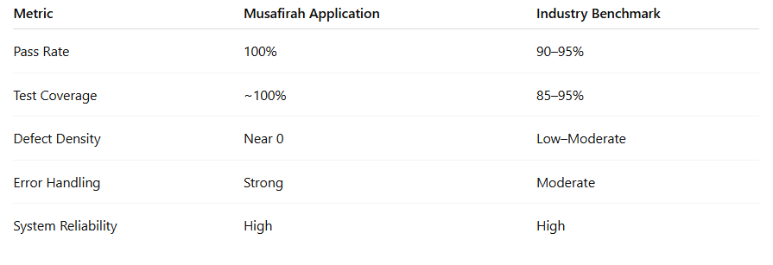
5. Critical Evaluation
While the results are highly positive, there are important considerations:
- The absence of failed test cases may indicate limited stress testing or performance testing.
- Real-world scenarios (e.g., high user load, network latency) may reveal issues not captured in functional testing.
- Quantitative metrics such as execution time, response time, and scalability are not included in the document.

Chapter 5

User Interface / Demonstration

5.1 Login Interface
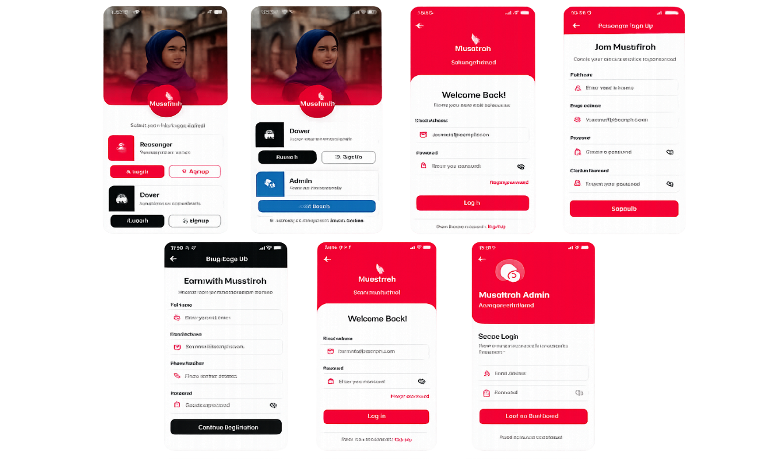
These screens represent the role selection interface of the Musafira mobile application, designed with a modern and user-friendly layout. At the top, a visually engaging banner image with a red gradient overlay creates a strong brand identity, complemented by a centered circular logo that adds emphasis and balance to the design. The interface guides users to choose their role, ensuring a smooth onboarding experience.
The second screen introduces the Passenger option, allowing users to quickly access ride-booking services. It features clear call-to-action buttons for Log In and Sign Up, styled with a bold red theme to attract attention. Below, the Driver section provides similar options for individuals who want to earn by offering rides, using a darker color scheme to differentiate roles visually.
The first screen focuses on the Driver and Admin roles. The Driver section highlights flexible earning opportunities, while the Admin panel is designed for backend management, offering secure platform control with a distinct blue theme. Overall, the UI effectively uses color coding, icons, and spacing to distinguish roles, making navigation intuitive and enhancing user experience.

5.2 Dashboard / Main Panel
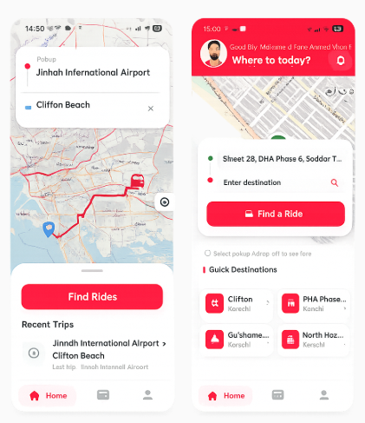
The first screen represents the Driver Interface of the Musafirah ride-sharing application. It allows drivers to view ride routes clearly on the live map, including pickup and drop-off locations. The interface displays the travel path from Jinnah International Airport to Clifton Beach with route tracking for better navigation and ride management. Drivers can quickly access recent trips and manage ride requests efficiently through a clean and user-friendly dashboard. The design focuses on simplicity, real-time navigation, and ease of use during driving operations.

The second screen represents the Passenger Interface of the Musafirah application. It provides passengers with a convenient platform to enter pickup and destination locations, search for available rides, and access quick destinations within Karachi. The interface includes personalized greetings, quick-access location cards, and an attractive modern layout to improve user experience. Passengers can easily book rides, view nearby destinations, and navigate through the application using the bottom navigation menu. The overall design emphasizes comfort, accessibility, and a smooth ride-booking experience for women users.

5.3 Other Screens
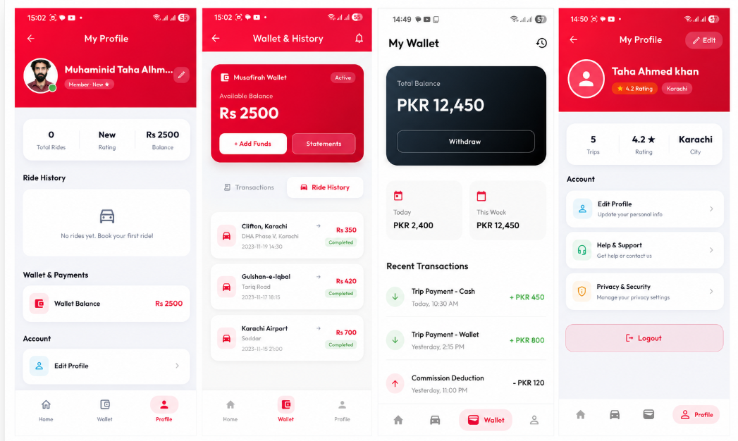

The first two screens represent the Passenger Module of the Musafirah ride-sharing application. These interfaces are designed to provide passengers with a secure, smooth, and user-friendly travel experience. The passenger profile screen displays personal information, ride statistics, wallet balance, and account management options such as profile editing and payment settings. The wallet and ride history screen allows users to manage their digital wallet, add funds, and track completed rides along with fare details and transaction history. The modern interface, soft color palette, and organized layout improve usability and accessibility for daily ride booking operations.
The remaining two screens represent the Driver Module of the Musafirah application. These interfaces are specifically designed for drivers to monitor earnings, manage rides, and maintain account information efficiently. The wallet dashboard provides drivers with details about total balance, daily and weekly earnings, withdrawal options, and recent payment transactions. The driver profile screen displays driver ratings, trip statistics, city information, and account management features including privacy, support, and profile editing options. The clean and professional design helps drivers easily manage financial activities and ride operations while ensuring a seamless user experience.

Chapter 6

Conclusion & Future Work

6.1 Limitations
Technical Limitations
- The application depends heavily on stable internet connectivity for Firebase synchronization, GPS tracking, map navigation, and real-time ride updates.
- In areas with weak internet coverage, users may experience delays in notifications, navigation accuracy, and live ride synchronization.
- The system currently relies on Stripe for online payment processing, which may face deployment and accessibility limitations in Pakistan due to international transaction dependencies.
- Integration with local payment gateways such as Easypaisa, JazzCash, and NayaPay has not yet been implemented.
- Advanced AI-based features such as predictive traffic analysis, smart ride recommendations, and automated fraud detection are not available in the current version.
- The current infrastructure is designed for limited-scale deployment and may require further optimization for handling large numbers of concurrent users.
Functional Limitations
- The CNIC and selfie verification process requires manual approval by the admin, which may slow down user onboarding as the platform grows.
- The application currently focuses mainly on short-distance urban transportation and does not support intercity ride-sharing services.
- The platform is limited to women-only users and does not currently support family accounts or corporate ride-sharing options.
- Offline functionality is not available, meaning users cannot access ride services without an internet connection.
- Features such as ride scheduling, multilingual support, and voice assistance are not included in the current implementation.
- Emergency support is currently limited to SOS alerts and trusted contact notifications without direct integration with law enforcement or emergency response authorities.

6.2 Conclusion
The Musafirah project was developed to address the growing safety and mobility concerns faced by women in Pakistan during daily travel. Existing ride-hailing services provide convenience but often fail to offer a trusted and women-exclusive environment that prioritizes safety, transparency, and comfort. To overcome these issues, Musafirah introduced a secure women-only carpooling platform designed specifically for female passengers and drivers.
The application was successfully developed using Flutter as the frontend framework and Firebase as the backend infrastructure for authentication, cloud storage, and real-time synchronization. Additional technologies including OpenStreetMap, OSRM navigation services, Google ML Kit OCR, and Stripe payment integration were utilized to create a complete and modern transportation solution.
Several important features were implemented, including OTP-based authentication, CNIC and selfie verification, live GPS tracking, SOS emergency alerts, trusted contact notifications, ride request management, in-app chat, real-time ride synchronization, digital wallet handling, and secure online payment processing. The system also included separate modules for passengers, drivers, and administrators to ensure organized management and better security control.
Testing and evaluation demonstrated that the application performs efficiently in handling ride coordination, user authentication, and real-time communication between drivers and passengers. The project also provided valuable practical experience in mobile application development, API integration, cloud databases, payment gateway integration, software testing, UI/UX design, and scalable system architecture.
Overall, Musafirah is not only a successful Final Year Project but also a socially impactful initiative aimed at empowering women by providing safer, more accessible, and technology-driven transportation services in Pakistan.

6.3 Future Directions
The future scope of Musafirah is broad and offers significant opportunities for technical enhancement and large-scale deployment. One of the major future improvements includes integrating local Pakistani payment gateways such as Easypaisa, JazzCash, and NayaPay alongside Stripe to provide more accessible and region-friendly digital payment options for users.
Artificial Intelligence and Machine Learning can be incorporated in future versions to improve ride matching, route optimization, fraud detection, and personalized ride recommendations. AI-driven analytics may also help predict traffic conditions, estimate ride demand, and improve overall transportation efficiency.
Future development may include biometric identity verification such as facial recognition and liveness detection to strengthen account security and reduce fake registrations. Integration with emergency response authorities and women safety helplines can further improve user protection during critical situations.
The platform can also expand beyond urban areas into semi-urban and rural regions to improve transportation accessibility for women throughout Pakistan. Additional features such as multilingual support, ride scheduling, voice assistance, carpool subscriptions, vehicle insurance integration, and AI-powered chat support can further enhance user experience.
From a technical perspective, Musafirah can evolve into a scalable cloud-native ecosystem capable of supporting thousands of concurrent users through microservices architecture, advanced monitoring systems, and automated deployment pipelines. In the long term, the platform has the potential to grow from an academic project into a commercial startup that contributes toward women empowerment, safer mobility, and smart transportation systems in Pakistan.

References
- Google. (2025). Flutter Documentation. Retrieved from
Flutter Official Documentation
- Firebase. (2025). Firebase Documentation. Retrieved from
Firebase Official Documentation
- Dart Team. (2025). Dart Programming Language Documentation. Retrieved from
Dart Official Website
- OpenStreetMap Contributors. (2025). OpenStreetMap Project. Retrieved from
OpenStreetMap
- Project OSRM. (2025). Open Source Routing Machine Documentation. Retrieved from
OSRM Official Documentation
- Google Developers. (2025). ML Kit Text Recognition API. Retrieved from
Google ML Kit
- Stripe Inc. (2025). Stripe Payment Infrastructure. Retrieved from
Stripe Official Website
- Google Developers. (2025). Firebase Authentication. Retrieved from
Firebase Authentication Docs
- Google Developers. (2025). Cloud Firestore Documentation. Retrieved from
Cloud Firestore Docs
- Geolocator Package Contributors. (2025). Flutter Geolocator Package. Retrieved from
Geolocator Package
- Flutter Map Contributors. (2025). Flutter Map Package Documentation. Retrieved from
Flutter Map Package
- International Finance Corporation (IFC). (2018). Driving Toward Equality: Women, Ride-Hailing, and the Sharing Economy. Retrieved from
IFC Official Website
- GitHub. (2025). GitHub Version Control Platform. Retrieved from
GitHub Official Website
- Microsoft. (2025). Visual Studio Code Documentation. Retrieved from
Visual Studio Code
- Google. (2025). Android Studio Developer Tools. Retrieved from
Android Studio Official Website

Appendices
Appendix A: Source Code Snippets
A.1 Firebase Authentication – User Login
Future<void> loginUser(String email, String password) async {
try {
await FirebaseAuth.instance.signInWithEmailAndPassword(
email: email,
password: password,
);
print("Login Successful");
} catch (e) {
print("Login Failed: $e");
}
}
A.2 CNIC Verification using Google ML Kit OCR
final textRecognizer = TextRecognizer(
script: TextRecognitionScript.latin,
);
final RecognizedText recognizedText =
await textRecognizer.processImage(inputImage);
for (TextBlock block in recognizedText.blocks) {
print(block.text);
}

A.3 Distance Calculation using Haversine Formula
static double getDistance(
LatLng origin,
LatLng destination,
) {
const double earthRadius = 6371;
final double lat1Rad = origin.latitude * (math.pi / 180);
final double lat2Rad = destination.latitude * (math.pi / 180);
return earthRadius;
}
A.4 Stripe Payment Integration
await Stripe.instance.initPaymentSheet(
paymentSheetParameters: SetupPaymentSheetParameters(
merchantDisplayName: 'Musafirah',
paymentIntentClientSecret: paymentIntent,
),
);
await Stripe.instance.presentPaymentSheet();
A.5 Firebase Firestore – Ride Data Storage
FirebaseFirestore.instance.collection('rides').add({
'pickup': pickupLocation,
'destination': destinationLocation,
'fare': rideFare,
'driverId': driverId,
'passengerId': passengerId,
});
A.6 SOS Emergency Alert Feature
void sendEmergencyAlert(String location) {
print("Emergency Alert Sent");
print("Current Location: $location");
}
Appendix B: Gantt Chart / Project Timeline
Project Phase | Duration
Project Planning & Proposal | Week 1 – Week 2
Requirements Analysis & SRS | Week 2 – Week 3
System Design & Architecture | Week 3 – Week 4
UI/UX Design & Prototyping | Week 4 – Week 5
Firebase Backend & Database Setup | Week 5 – Week 6
Security & Authentication Module | Week 6 – Week 7
Core Passenger & Fare Calculation Module | Week 7 – Week 8
Core Driver & Ride Matching Module | Week 8 – Week 9
GPS Tracking & Route Navigation Module | Week 9 – Week 10
Payment Gateway & Wallet Integration | Week 10 – Week 11
SOS Safety & Emergency Alert Module | Week 11 – Week 12
System Integration & Testing | Week 12 – Week 13
Deployment, Documentation & Viva Prep | Week 13 – Week 14

Project Tasks & Deliverables | W1 | W2 | W3 | W4 | W5 | W6 | W7 | W8 | W9 | W10 | W11 | W12 | W13 | W14
Project Proposal & Feasibility Study
SRS Document & Requirements Gathering
System Modeling (ERD, Use Case, Sequence Diagrams)
Figma Wireframes & Interface Design
Firebase Environment Setup & Console Config
Database Schema & Firestore Security Rules
User Registration & Phone OTP Verification Flow
CNIC OCR Document Extraction (Google ML Kit)
Selfie Upload & Face Liveness Verification
Passenger Pickup/Drop-off Location Pin Selection
Fare Estimation Engine (Haversine Formula Implementation)
Driver Ride Request Screen & Live Dynamic List
Real-time Ride Offer & Match Notifications (FCM)
Driver Ride Acceptance & Status State Management
OSRM Routing Engine & Map Polyline Drawing
Real-time Live GPS Tracking & Marker Interpolation
Stripe Payment Gateway SDK Setup & API Integration
Digital Wallet System & Top-up Feature (PKR/Card)
SOS Panic Button & Instant SMS/Emergency Alert Setup
Trusted Contacts Management Module
Unit Testing & API Integration Tests
Target User Beta Group Acceptance Testing
Final Thesis Writing, Formatting & Report Compilation
Final Video Demo, Slide Preparation & Viva Rehearsal
Production Build Compilation & Deployment

